MODEL EXAMINATION FOR C++ 27/02/2024

PROGRAM: 1

Pointer char if arrey:

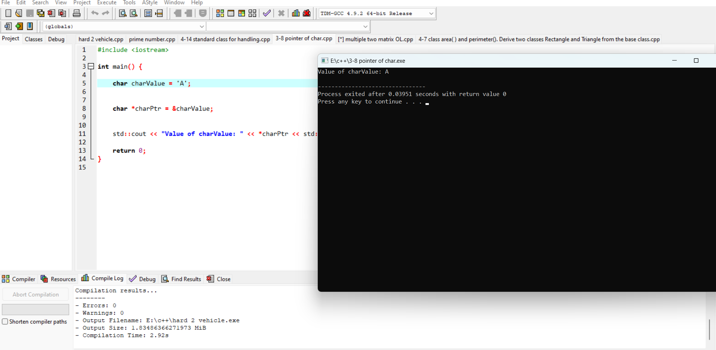

Program 2:

Eligible for vote or not:

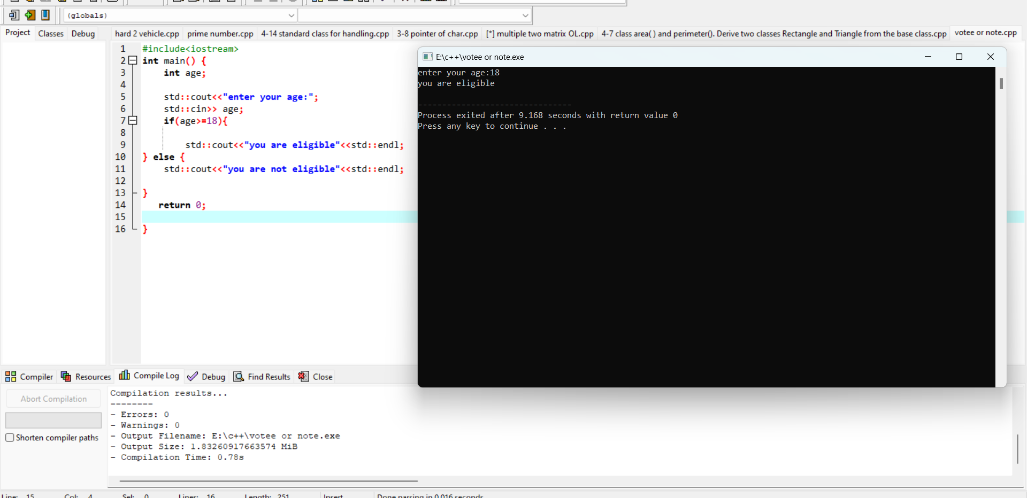

Program 3:

Prime or not:

Program 4:

Use of standard exception class for handling ?

Program 5:

Subtract two complex numbers:

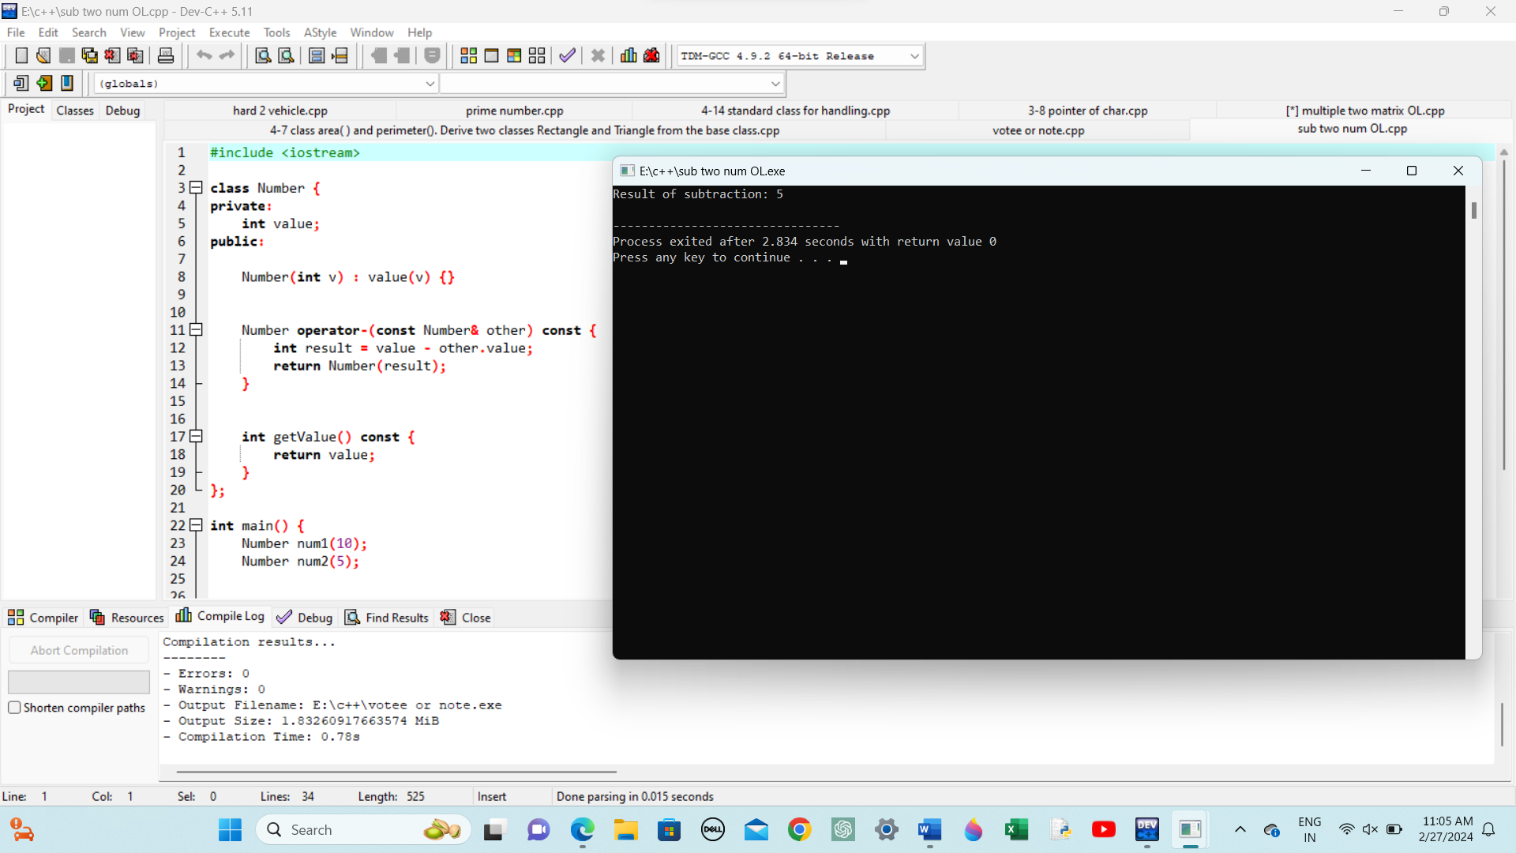Program 6:

Multiple two Matrix:



Program 7:

Library Management System

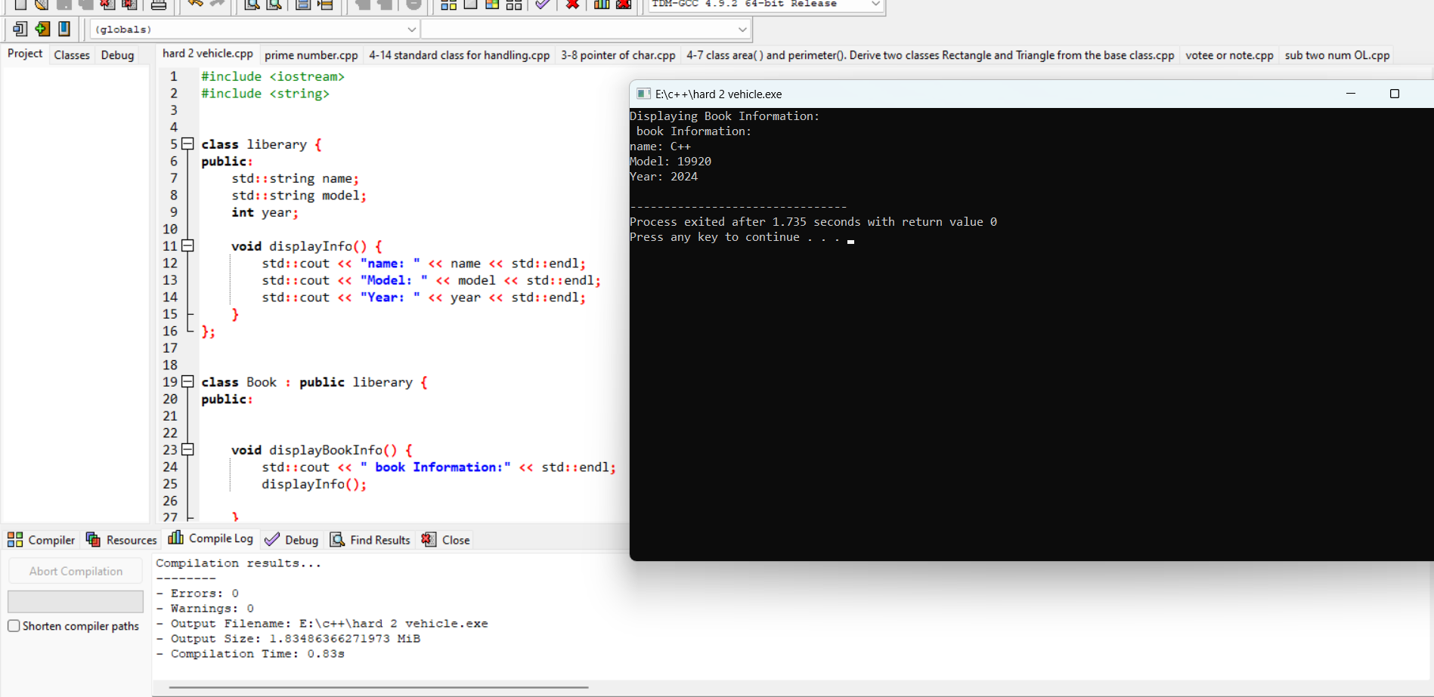

Program 8:

Bass class Shape of Rectangle and Triangle to find Area and Perimeter

